**Name- Alamin Sheikh**

**ID- 18-39230-3**

Performance Task for Lab Report: (your ID = AB-CDEFG-H)

**Generate a composite signal using two simple signals as,

x1(t) = A1 cos(2π(C*100)t )

x2(t) = A2 cos(2π(F*100)t)

x3(t) = x1(t) + x2(t)

**ID: 18-39230-3**

**A=1, B=8, C=3, D=9, E=2, F=3, G=0, H=2**

Matlab code:

A1=GD=09, A2=AF=13, C=3, F=3

**a)**

fs=1000;

t=0:1/fs:1-1/fs;

A1=9;

A2=13;

x1=A1*cos(2*pi*3*100*t);

x2=A2*cos(2*pi*4*100*t);

plot(t,x1,t,x2);

xlabel('Time in seconds');

ylabel('Amplitude in volts');

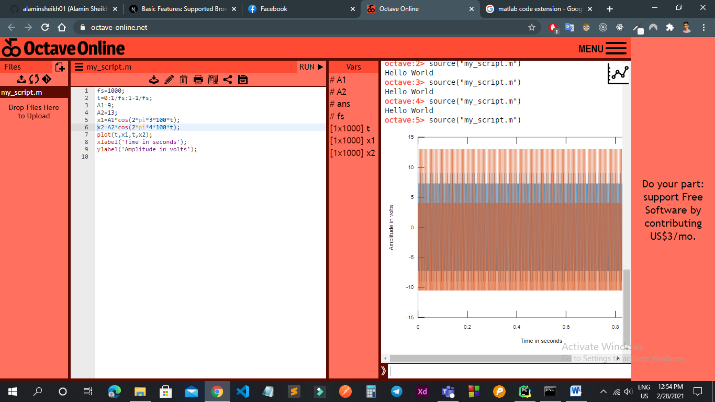

**b)**

fs=1000;

t=0:1/fs:1-1/fs;

A1=9;

A2=13;

x1=A1*cos(2*pi*3*100*t);

x2=A2*cos(2*pi*4*100*t);

x3=x1+x2;

plot(t,x3);

xlabel('Time in seconds');

ylabel('Amplitude in volts');

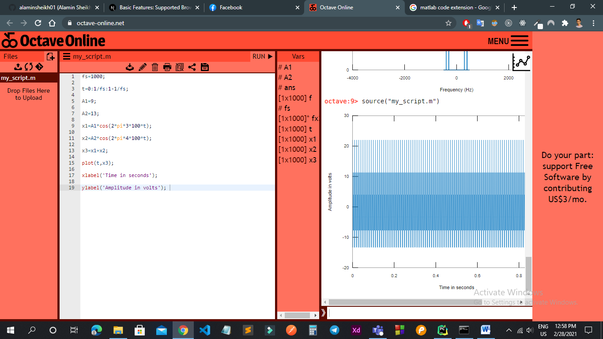

**c)**

fs=1000;

t=0:1/fs:1-1/fs;

A1=9;

A2=13;

x1=A1*cos(2*pi*3*100*t);

x2=A2*cos(2*pi*4*100*t);

x3=x1+x2;

fx3=fft(x3);

fx3=fftshift(fx3)/(fs/2);

f=fs/2*linspace(-1,1,fs);

figure;

plot(f,abs(fx3),'Linewidth',1.5);

axis ([-4000 4000 0 2]);

xlabel('Frequency (Hz)');

ylabel('Magnitude');

title('x3 in Frequency Domain');

